RUNIBEX TECHNOLOGY GROUP

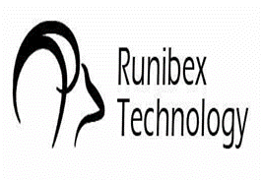

OUR QUALITY POLICY

Our Quality Policy, as a whole, for our group companies, pledges;

- The documentation, generalization, sustainability and communicability of our Quality Management System,
- The structuring of Corporate Performance and Corporate Risk Management Systems, periodic follow-ups and taking necessary actions,
- Achieving corporate goals,
- The continuous improvement of our business processes,
- Improving our competence through individual and teamwork training,
- Ensuring the satisfaction of our customers, suppliers and employees,
- Strengthening our corporate reputation and keeping our corporate values ​​alive,
- Compliance with all relevant national / international legislations,
- Effective management and continuous improvement of all our activities within the framework of our policies complying with ISO 9001: 2015 Quality Management System,
- Ensure the accessibility of this policy and increase awareness of our stakeholders,

Fatih OZBAGRIACIK
General Manager

PO.KY.01/0

